SQL fundamentals Query Activity:

1. Display the name of movies, movie type is starts with Drama.

>delimiter //

create PROCEDURE Getprod()

BEGIN

SELECT moviename,movietype FROM movie

where movietype like 'Drama%';

END //

delimiter ;

call Getprod;

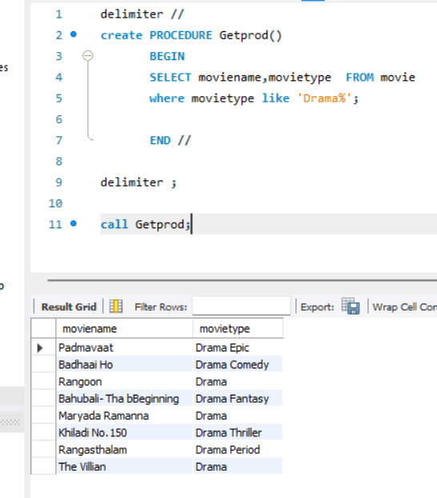

2. Display the movies acted by actor Ayushmann.

>delimiter //

create PROCEDURE Getprod()

BEGIN

SELECT count(moviename) FROM movie

where heroname= 'Ayushmann';

END //

delimiter ;

call Getprod;

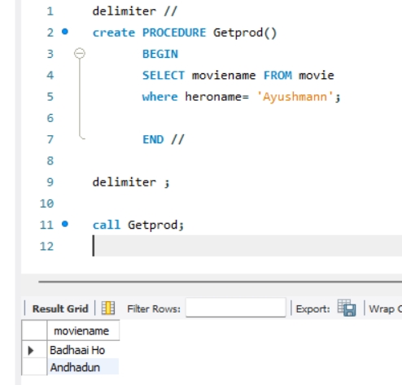

3. Display the count of movies, having length above 18.

>delimiter //

create PROCEDURE Getprod()

BEGIN

SELECT count(moviename) FROM movie

where length>18;

END //

delimiter ;

call Getprod;

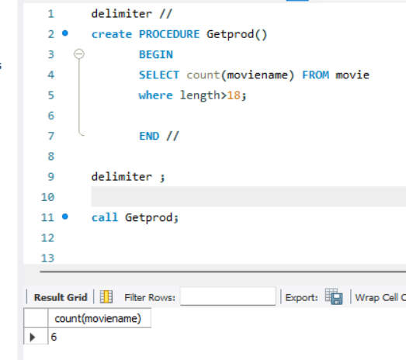

4. Display the movie having minimum length.

>delimiter //

create PROCEDURE Getprod()

BEGIN

SELECT moviename,heroname,heroine from movie

where length=(select min(length) from movie);

END //

delimiter ;

call Getprod;

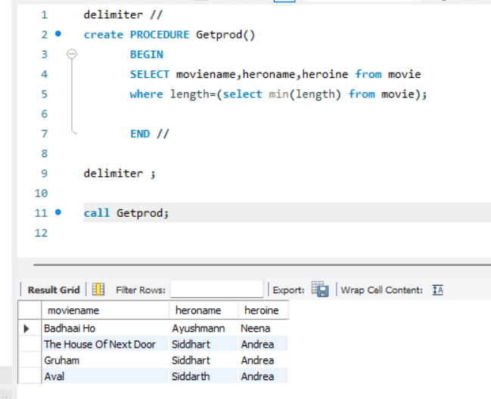

5. Display all the details of movie, the language that first name starts with ‘T

>delimiter //

create PROCEDURE Getprod()

BEGIN

SELECT \* from movie

where language like 'T%';

END //

delimiter ;

call Getprod;

